Final Project Design Phase
Computer Science - Week 11
Oct 3, 2026 - Version 0.0.4

For complete instructions and project ideas, refer to the assignment in Canvas. Specifically, review the final project requirements before you continue below. If you have not reviewed the project requirements in Canvas (you might have to go to the modules view and check the current or past week's content), you will not be able to properly complete the parts below. In addition, it may be helpful to review the information on this Drafter documentation page.

0) Project Planning and Preparation
Successful programmers spend time planning before they begin coding. After reviewing the project requirements, answer the following questions to help guide your design and development process.
- What concepts from class or previous assignments might help you complete this project? Which programming concepts (loops, conditionals, lists, classes, etc.) do you expect to use? What programming skills do you want to improve while completing this project?
I expect to use math, variables, functions, if statements, loops, lists, and dataclasses. I will store each resistor as an object in a list and use Drafter routes and buttons to connect the pages. I want to improve how I organize functions, work with lists of objects, validate input, and unit test calculations.

- Which parts of the project do you expect to be the easiest for you? The hardest? Why?
The series calculation should be easiest because it adds resistor values. Creating basic Drafter pages should also be manageable. The hardest parts will be applying the parallel formula and handling invalid inputs. I will use fixed series and parallel example images instead of generating large diagrams since that would be to hard to implement with hundreds of resistors.

- Even though you have not yet designed the final project, estimate which tasks will likely require the most time and effort? Which features or components should be implemented first?
Connecting the routes, validating inputs, and testing calculations will probably require the most effort. I will create the dataclasses and page navigation first, then add and remove resistors. Then I will implement settings, resistance and current calculations, error messages, and results. I will finish with the example diagrams, and guide page

- What distractions might interfere with your work and how will you minimize them? What resources will you need available while working? What questions, if any, do you still have about the assignment requirements?
Texts and unrelated tabs could distract me, so I plan to silence my phone and work in focused sessions. I will need the course textbook, the initial design/requirements, Drafter documentation, my Python editor, and known circuit examples.

1) Site Diagram
Create a mock-up of your planned website. We suggest you make the mockup on paper, although you can also use software like PowerPoint or Slides to make a mockup. There is other design software that could also be used, but we strongly encourage you to keep it simple. Do not spend more than 15-30 minutes detailing the mock-up. Your goal should be to make a very quick and dirty diagram, to show that you have some kind of idea.

We recommend drawing each page as a rectangle, and laying out the text, buttons, and other components inside. Then, use arrows to indicate links between pages. Label each page the way you will name each function, and then put labels on the arrows to indicate what the button links. Also write down any parameters that should come into the pages.

In addition to the pages and routes, write down what fields your `State` will have, both their names and types. Think clearly about what data will need to be persistent across the entire website.

Add photo(s) or screenshot(s) of your website mock-up and labeled diagram on the next page.
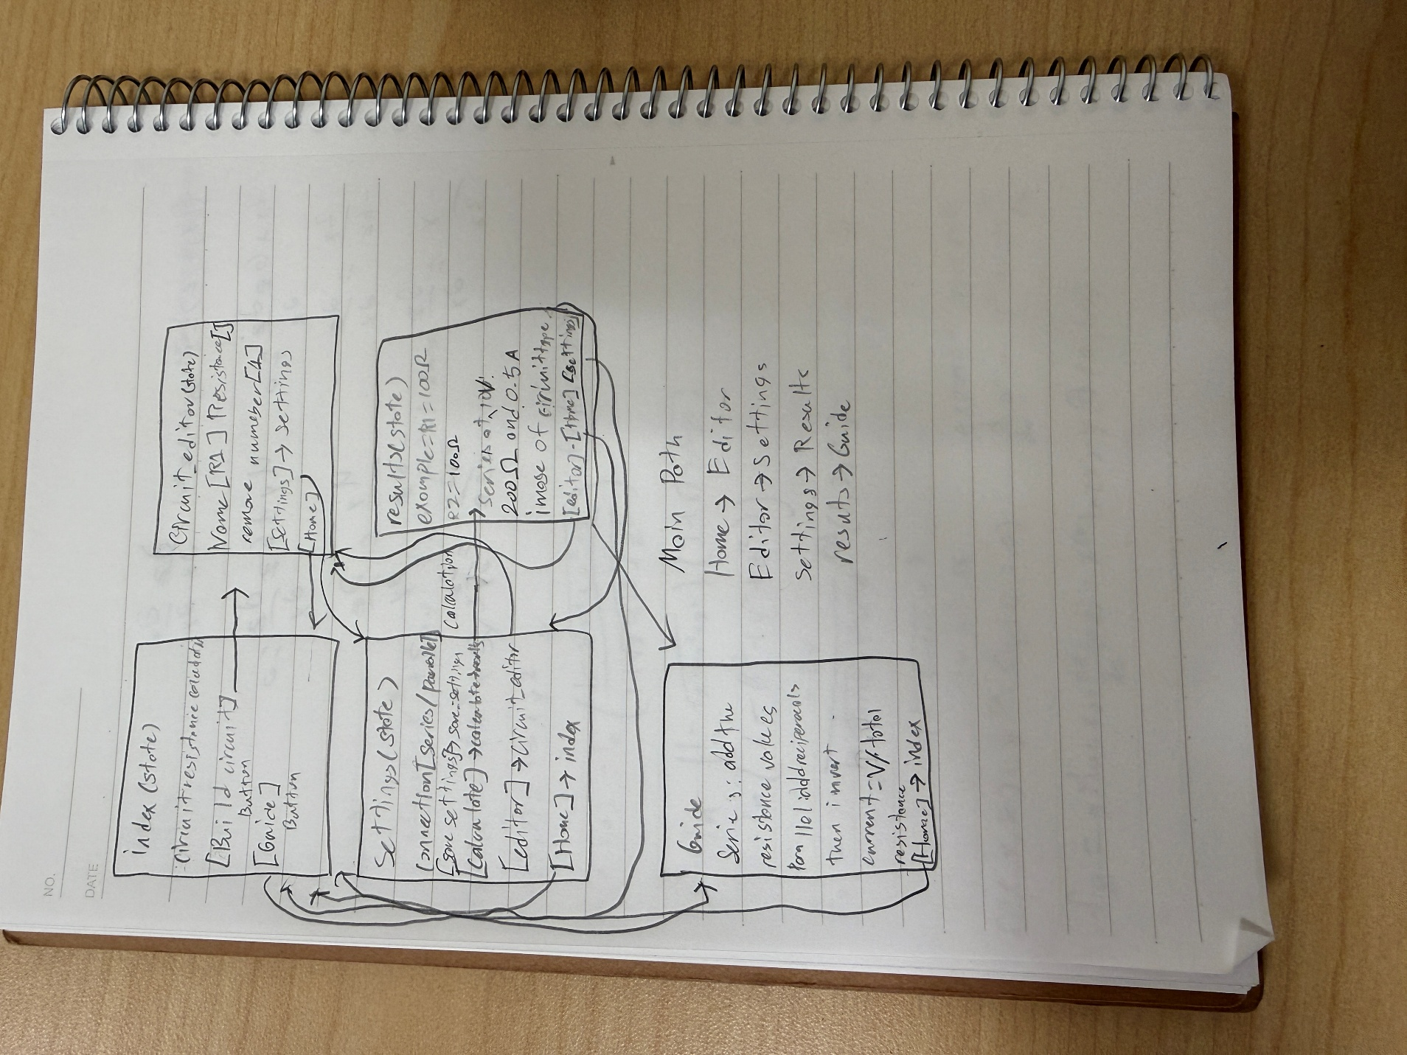
2) Implementing Requirements
This table should serve as a draft for how you will implement the requirements into your final project. You may change your ideas later on, but your final site must fulfill all the requirements.

Requirement | Implementation
Purpose/Functionality  A 1-2 sentence description of the purpose or functionality of your site | My site will calculate total resistance and total current for an ideal resistor circuit connected in series or in parallel. It will show the actual resistor list, an example diagram of the connection type.
State Dataclass Attributes  Minimum of 4 attributes, one of which must be a list/dict of instances of your second dataclass.  Briefly describe each attribute, its type, and how it will be meaningfully modified throughout the site. | resistors: list[Resistor] stores the circuit components where add_resistor appends objects and remove_resistor removes them.  circuit_type: is a string that stores Series or Parallel in save_settings which modifies State and calculate update it from the selector.  voltage: is a float that stores the supply voltage in save_settings which modifies State and updates it from user input.  feedback: is a string that stores an error or confirmation, routes change it when inputs are invalid  All four fields change meaningfully. Totals are calculated from current State whenever the results page is displayed.
Second Dataclass  Your second dataclass, including its attributes, their types, and how they will be meaningfully modified (if they are modified) | Resistor has name: str, such as R1, and resistance: float, measured in ohms. add_resistor creates each object from user input and stores it in state.resistors. The user can remove and replace them but not edit them. Calculations read each object's resistance attribute.
Routes (minimum 7)  The names of your route functions | Nine route functions: index, circuit_editor, settings, results, guide, add_resistor, remove_resistor, save_settings, and calculate.  The first five display website pages. The final four process actions and return an existing page. All receive state: State.
Pages (minimum 5)  A brief description of the pages in your site | 1. index: Home with a description and links to the editor and guide.  2. circuit_editor: Add or remove resistors and review the list.  3. settings: Choose series or parallel, provide voltage.  4. results: Show resistance, current, and a fixed example diagram.  5. guide: Explain formulas, units, assumptions, and a worked example.
User Input (minimum 3)  Description of user input components (TextBox, TextArea, CheckBox, or SelectBox) and their purposes  For more information on these input types, see Drafter Documentation. | resistor_name TextBox: resistor name.  resistance TextBox: positive resistance in ohms.  circuit_type SelectBox: Series or Parallel.  voltage TextBox: supply voltage in volts.
If Statements (minimum 3)  Brief description of what will be evaluated in your if statements and how they will meaningfully change the logic of the site | If resistance is zero or negative or the name is blank, reject the resistor and display an error.  If the removal number is outside the list, display an error.  If there are no resistors, return to the editor instead of calculating.  If voltage is negative, reject the settings.  If the circuit type is Series, add values; otherwise apply the parallel formula(this is going to be a function).
Loop (minimum 1)  This loop must iterate over the list/dict of dataclass instances in your State attribute.  Description of this loop and why it is meaningful to the site | A loop iterates over state.resistors and take each resistor.resistance. For a series circuit it adds those values to a running total. For parallel circuits it adds their reciprocals, then inverts the sum using a helper function. This loop directly determines total resistance. Total current is voltage divided by total resistance. For example, two 100 ohm resistors at 10 V give 200 ohms and 0.05 A in series, or 50 ohms and 0.2 A in parallel.

LLM Conversation
If you used an LLM in any part of this work, copy and paste every part of that conversation below. Otherwise, you may be given a zero for the assignment. Obviously, these words will not all be yours, and this is the exception to the requirement at the top of this assignment that all responses be in your own words. If you did not use an LLM to assist you in this assignment, simply say so below.
what should I use to keep track of resistor names in a list, should I use indexing? or add a field for the name of the resistor and use that for removal
4:30 PM
Add a name field to your Resistor dataclass and use that name for removal. Store each resistor object in your list:
@dataclass
class Resistor:
name: str
resistance: float
For example, the list could contain:
[
Resistor("R1", 100.0),
Resistor("R2", 220.0),
Resistor("R3", 330.0)
]
When the user enters "R2", loop through the list and compare it with each resistor’s name. One beginner-friendly approach is to build a list containing everything except the matching resistor:
remaining = []
found = False

for resistor in state.resistors:
if resistor.name == resistor_name:
found = True
else:
remaining.append(resistor)

state.resistors = remaining

if found:
state.feedback = "Resistor removed."
else:
state.feedback = "No resistor with that name was found."
Require unique names when adding resistors, so removing a name identifies exactly one component.
Indexes represent positions and change when items are removed. A name such as R3 stays attached to its resistor even when its position changes.

Final Submission
When you are finished, download this file as a Word Document (docx) and upload the file to the appropriate assignment on Canvas.

